  - Introduction

  - Overview

Congratulations on your new scale.
This robust scale with its battery operation, connectable cash drawer and integrated ticket printer facilitates comfortable, mobile selling while maintaining the highest accuracy.
Your new scale not only stands out due to its mobility, but also due to its network-capability and fast data transfer to and from a computer. This lets you, for example, operate integrated scales which are connected to quickly and easily create sales reports.

  - Service Facilities

To service a scale, the service area should meet the following requirements:

- Should be temperature controlled and meet scale specifications for ambient temperature requirements.
- Must be free of vibrations, such as fork lift trucks close by, large motors, air currents or drafts from air conditioning/heating ducts, open windows, people walking by, fans, etc.
- Area must be clean and free of excessive dust.
- Work surface must be stable and level.
- Scale must not be exposed to direct sunlight or radiating heat sources.
- Use an approved electro-static device.

  - Tools & Test Equipment Required

- Common hand tools are sufficient to disassemble bPlus scales. (A list of tools can be found under 6.1 service preparation)
- RS232 or Ethernet connectors
- PC Tools provided by manufacturer

  - System Specifications

- The specifications of bPlus series are listed in the below table
- Before servicing a scale, first determine which parameters are not met
- After servicing the scale, the below specifications must be met

Model Options* | Caesar T2/H2: 3/6kg, 6/15kg, 15/30kg (Dual range)
Display* | Segement display, 1-dot matrix display with orange backlight, 1-dot matrix display with white backlight,
Key | 98 keys
Preset key | 132 keys(two levels)
Stainless steel pan | 390x286mm
Power | 100~240VAC, 50/60Hz
Gross weight/Net weight | 10kg/8kg
Shipping box | 575x560x190mm
Working environment | Temerature:-10°C~+40°C; Humidity:85%RH, non-condensation
Storage environment | Temerature:-25°C~+50°C; Humidity:85%RH, non-condensation
Weighing function | Zero, Tare, 100g*, 500g*, Change*
Communication | RS232/USB
Accessories | Power cord, manual

*Not available in all countries

    - Model Configuration

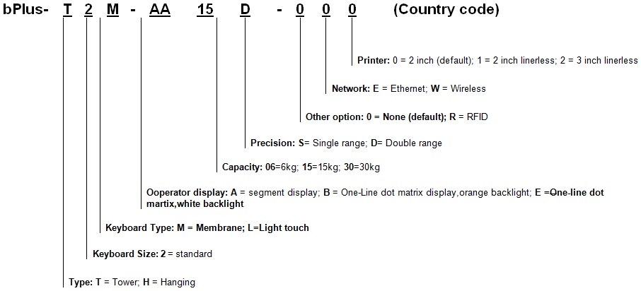

1.4.2 Approval Documentation

- CE
- CMC

2.0 Installation

Before installing your bPlus scale, identify the best location for your new equipment. A suitable installation environment enhances operation and ensures a long life of the scale. Keep in mind the following factors, which might have a negative influence on the scale's performance:
- Vibration diminishes the scale’s ability to measure accurately. Excessive vibration from equipment such as conveyors can cause inaccurate and non-repeatable readings.
- Be sure the scale is leveled properly.
- Air currents can also diminish a scale’s performance.
- Avoid placing the scale in front of or directly under air vents.
- Other than items being weighed, avoid any objects rubbing or pressing against any part of the scale.

2.1 Safety Precautions

In order to prevent accidents at work, the installer is required to take actions, directions and measures that comply with the general regulations for the prevention of industrial accidents, all other valid regulations for the prevention of accidents and with all other generally recognized regulations relating to safety and occupational health (excerpt from paragraph 2 of the German “Unfalllverhütungsvorschriften” General Regulations for the Prevention of Industrial Accidents).

2.2 Ambient Conditions

The right location is critical to weighing accuracy. Ideal locations comply with the following conditions:

- No shocks and vibrations
- No excessive temperature fluctuations
- No direct sunlight
- No strong drafts
- Select a vibration-free location for your scale

3.0 Service Setup

3.1 Entering Service Setup

- Press [Menu] key. Input the default password 2666666 and press [OK] to enter the menu.
- Press the arrow up or down key to select Menu 9 “Service” and press [OK] key.
- Input the default password 246813 and press [OK] to enter the menu.

3.2 Setup Navigation

The following keys can be used during setup:
Enter the menu

Confirm selection / complete entry

Go back a level

Go up

Go down

Go left

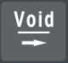
Go right

3.3 Ending Setup

Press [Back] key to end setup.

3.4 Group 5 Service Settings

No. | Display | Description | Possible Values
F9 Service
F91 | Country Setting | Set up country information
 | Country | Select country
 | Price Format  - Currency Symbol  - Currency Position  - Format Locked  - Total Price Digits  - Total Price Rounding  - Total Price Resolution  - Total Sales Digits  - Total Sales Rounding  - Total Sales Resolution  - Decimal Separator  - Grouping Place  - Grouping Separator | Set up price format | $/￡/Fr/...  Prefix/Postfix  All/Digits/No  0 … 6  Down/Middle Down/  Middle Up/Up  1 … 1000000  0 … 6  Down/Middle Down/  Middle Up/Up  1 … 1000000  ./,  0 … 3  0 … 1
 | Show Negative Weight | Allow show negtive weight | Yes/No
 | Min Booking Weight | Select minimum booking weight | 1 1e  2 5e  3 10e  4 20e
 | Allow Chain Tare | Allow chain tare | Yes/No
 | Display Unit of Measure | Allow display unit of measure | 1 Auto  2 KGM  3 GRM  4 100g
 | Calibration | Start calibration process
 | Filter | Select filter speed | 1 Low  2 Medium  3 Fast
F94 | Printer | Set up printer
 | Paper Take-up Sensor | Allow paper take-up sensor | Enable/Disable
 | Out of Paper Sensor | Allow out of paper sensor | Enable/Disable
 | Print Speed | Select print speed | 1 60 mm/s  2 70 mm/s  3 80 mm/s  4 90 mm/s  5 100 mm/s
 | Print Contrast | Select print contrast | 1 +4  2 +3  3 +2  4 +1  5 0  6 -1  7 -2  8 -3
 | Printing Test | Start printing test process
 | Roll Back | Allow roll back | Enable/Disable
 | Roll Back Offset | Set up roll back offset | 0 … 100
 | Gap Type | Select gap type | 1 Normal  2 Black  3 None
 | Liner | Select liner | 1 ClockWise  2 Counter-ClockWise  3 Stop
 | Position Sensor Value | Set up position sensor value
 | Temperature Sensor | Allow temperature sensor | Enable/Disable
 | Temperature Sensor Value | Set up temperature sensor value
 | Calibrate Pos Threshold | Start calibration process
 | Calibrate Out of Paper Th… | Start calibration process
 | Magnification of 2D barcode | Set up magnification of barcode | 2 … 4
F96 | Preventive Maintenance | Start maintenance process
 | Replace Keyboard | Start keyboard replacement
 | Replace Print Head | Start print head replacement
 | Print maintenance Info | Print information of maintenance
F97 | Testing | Start testing
 | Keyboard Test | Start keyboard testing
 | Display Test | Start display testing
 | Printer Test | Start printer testing
 | Extend Weight | Start weight extension
 | DebugPort | Select debug port | 1 None  2 Output  3 MT-SICS

3.6 Printing
Edit and print labels with Smart Label (Export interface, SL labels and printed labels)

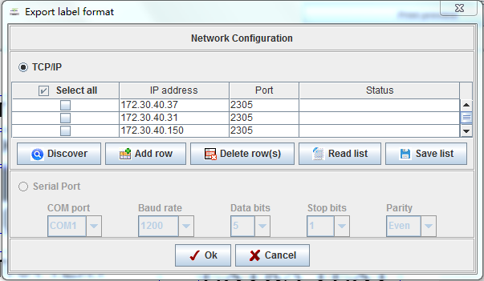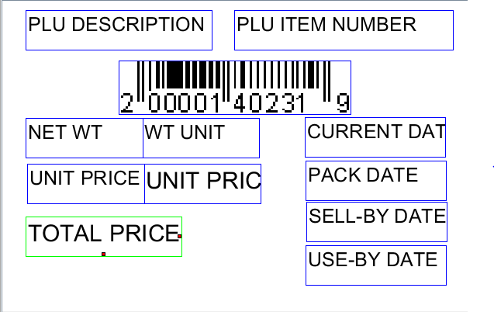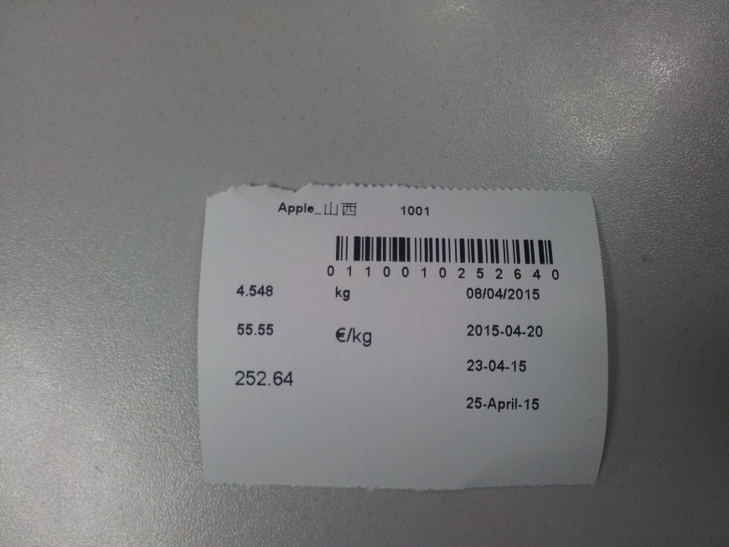

3.7 Calibration

Important Note:

Assuming the user is to use the (non-automatic) scales/balance in the legally regulated field, the user will be responsible for notifying the competent calibration authorities of the repaired scales/balance, so that the latter can take the appropriate measures (calibration/recalibration).

- Press [Menu] key. Input the default password 2666666 and press [OK] to enter the menu.
- Press the arrow up or down key to select Menu 9 “Service” and press [OK] key.
- Input the default password 246813 and press [OK] to enter the menu.
- Press the arrow up or down key to select Menu “Calibration” and press [OK] key.
- Press the calibration button.
- Select Menu “Calibration” again and press [OK] key.
- Select "Filter" and press [OK] key. Press arrow down key to select a filter e.g. Filter > Medium and press [OK] key.
- Select "Geo Code" and press [OK] key. Press arrow down key to select a geo code e.g. Geo Code > 12 and press [OK] key.
- Select "Calibrate" and press [OK] key.
- Select "Unit" and press [OK] key. Press arrow down key to select a unit e.g. Unit > kg and press [OK] key.
- Select "Range" and press [OK] key. Press arrow down key to select a range e.g. Range > Dual and press [OK] key.
- Select "Capacity" and press [OK] key. Press arrow down key to select a capacity e.g. Capacity > 15kg and press [OK] key.
- Select "Resolution" and press [OK] key. Press arrow down key to select a resolution e.g. Resolution > 0.005 and press [OK] key.
- Select "Zero" and press [OK] key.
- Select "Load" and press [OK] key. Press arrow down key to select a load e.g. load >10kg and press [OK] key.
- Put the weight on the platter.
- Finish, press [OK] to restart.

4.0 Maintenance

4.1 Preventive Maintenance

MT scales are precision instruments which should be handled carefully, stored in a clean, dry, dust-free area, and cleaned periodically. Follow these precautionary steps:

- When a scale has had chemicals or liquids spilled on it, all exterior surfaces should be cleaned as soon as possible with warm water on a damp cloth.
- Do not leave any weights on the scale when the scale is not in use.
- Allow time for the scale to stabilize after moving it from an area which is at a different temperature than the area where it is to be operated. Allow one hour for each 5°F (2.7°C) temperature change before using the scale. After temperature stabilization, allow an additional 20 minutes after turning the scale on, for the scale electronics to stabilize.

Preventive Maintenance Checklist

The scale should be inspected and checked regularly, as follows:
- Clean the outside of the scale using a damp cloth with warm water.

CAUTION:
DO NOT USE CHEMICAL CLEANERS OR SOLVENTS OF ANY TYPE. SOME CLEANERS ARE ABRASIVE AND MAY AFFECT THE SCALE’S FINISH.

2. Check to ensure that the power cord is not broken and has no damaged insulation.
3. If using batteries and the scale malfunctions, first replace the batteries to see if this resolves the problem.
4. Make a visual inspection for faulty connectors, wiring, and loose hardware.

4.2 Troubleshooting

This section of the manual contains troubleshooting information. It includes information to isolate specific problems step by step. Before doing any such work, make certain that your working area is clean, that you handle all scale components with care, and that you use a suitable electro-static device.

Diagnostic Guide:

Scale inoperative / blank displays

1. Check AC power at outlet. If voltages are zero, check and replace fuse
2. Check voltage on power supply. If voltage at outlet is zero, replace power supply
3. Check voltage on DC/DC to see if there is 5V DC or 8V DC at the outlet. If the voltage is zero, replace DC/DC
4. Check whether the harnesses are properly connected
5. Try to press the keyboard. If you can hear a beep while pressing the keyboard, replace the display. Otherwise please replace the mainboard.

Keyboard inoperative

1. Check keyboard connection on main board, ensuring it is securely plugged in.
2. If all connections are secure and keyboard is inoperative, replace keyboard.

Can’t communicate via Ethernet

1. Check the IP settings in setting 702
2. Check whether the LED light lights up. If it is not lit or does not flash:

-Replace the Ethernet harness
-Replace the interface board
-Replace the main board
-Check whether the network license is active when trying to work on a floating vendor

Print white paper

1. Check the harness, ensuring it is secure
2. Replace the printer
3. If it is still inoperative, replace mainboard

Weighing not stable

1. Check the harness of the load cell
2. Check whether there is something touching the load cell
3. Replace the AD board or load cell

4.3 Warning & Error Shooting
The table below is a diagnostic guide designed to help users locate the problem area quickly & easily. The probable causes are listed with the most common causes first. If the first remedy does not fix the problem, proceed to the next remedy. Before attempting to repair the scale, read all chapters of the manual to be familiar with the scale components & their operation.
Warning information will occur when an operation is wrong. Usually this information is displayed on the bottom line for about 1 second. It can be cleared by pressing key [C].

4.4 Diagnosis

1. Isolate and identify the symptom
2. Refer to the diagnostic guide and locate the symptom. (Please also refer to the Troubleshooting chapter)
3. Follow the suggested remedies in the order they appear.
4. Perform the indicated checks, or refer to the appropriate section of the manual.
5. Repair or replace the defective section of the scale.

NOTE:

If more than one symptom is observed, approach one area at a time, and remember that the symptoms may be interrelated.

If a problem arises that is not covered in this manual, contact us for further information.

Group nine of the setup menu enables you to run functionality tests on dedicated devices. The functionality tests will help verify your diagnosis.

5.0 Replacing Parts

Before servicing the scale, always unplug the power cord from the scale.
Only qualified service staff may open the scale for service purposes.
Be aware of any static charges and wear a static-proof wrist belt when touching the PCB.

5.1 Service Preparation

Use the below procedures to replace the main board, displays, load cell, A/D printed circuit board, main fuse and DC/DC printed circuit board.

Important Notice:

Assuming the user is to use the (non-automatic) scales/balance in the legally regulated field, the user will be responsible for notifying the appropriate calibration authorities of the repaired scales/balance, so that the latter can take the appropriate measures (calibration/recalibration).

After replacing the main board or parts used in the actual measurement process, the following steps must be performed:

- Check & set the local geo code setting (geo code for the region in which the product is to be used)
- Check calibration reproducibility, linearity, eccentricity)
- Apply local currency/country setting
- Run final functionality test

Preparations before opening the housing (if possible):

- Back-up data & operational settings via PC program.

Attention: Use the clone function of the PC program only if you intend to install the same software version after the service work.

- Note down license level (group 306)
- Verify the software version installed
- Check the geo code
- Check the language setting

Repair Tools:

The repair of bPlus requires a common set offhand tools including, wrenches, screwdrivers, hexagon bolt tools.

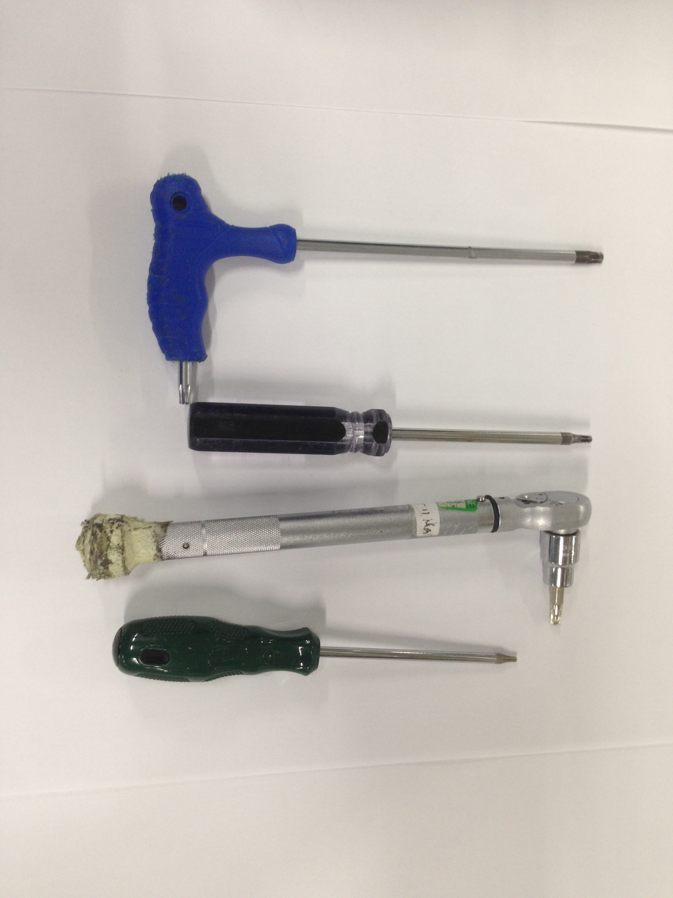

5.2 Opening the Housing

Important notice: Please refer to the Service Preparations chapter before opening the housing.

5.3 Replacing the Main Board

Preparations:

Procedure for replacing the board:

1. Lift off the platter and open the top housing (for details, please refer to the Opening the Housing chapter)
2. Unscrew the 4 PCB bolts
3. Disconnect all cables plugged into main PCB
4. Remove the old main board
5. Install the new main PCB following the same instructions in the reverse order
6. Install the top housing

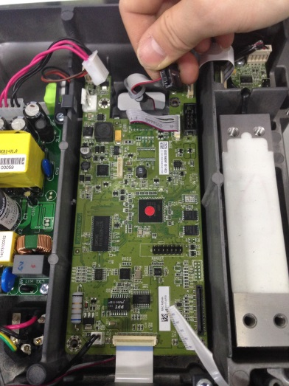
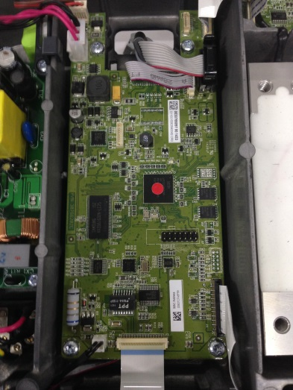
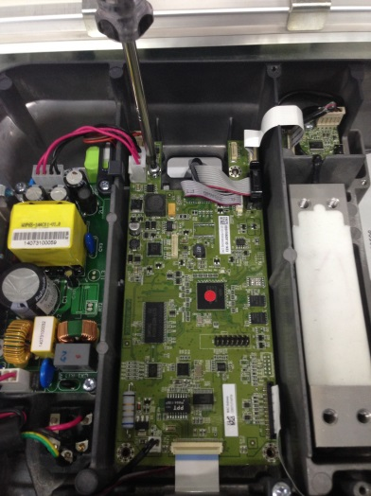

Procedure for restoring the system

Assuming the user is to use the (non-automatic) scales/balance in the legally regulated field, the user will be responsible for notifying the appropriate calibration authorities of the repaired scales/balance, so that the latter can take the appropriate measures (calibration/recalibration).

Important note: Information regarding Calibration & testing can be found in chapters 6.7 & 3.7.

5.4 Replacing a Power Switch

Procedure for changing the board:

1. Lift off the platter and open the top housing (for details, please refer to the Opening the Housing chapter)
2. Unscrew the 4 PCB bolts
3. Disconnect all cables plugged into power switch PCB
4. Remove the old power switch
5. Install the new power switch following the same instructions in the reverse order
6. Install the top housing

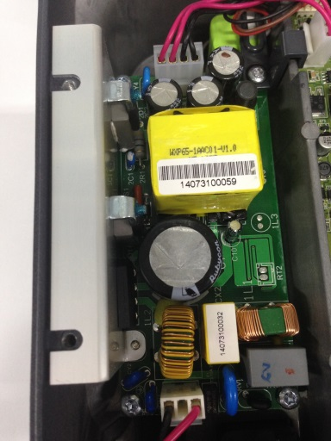
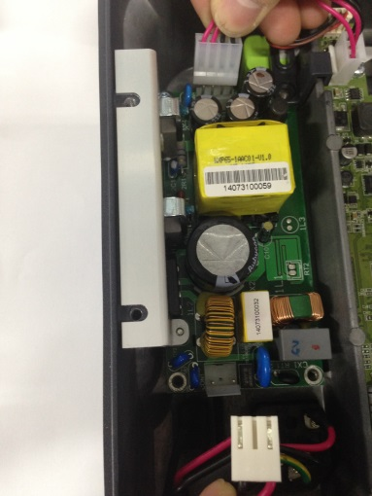
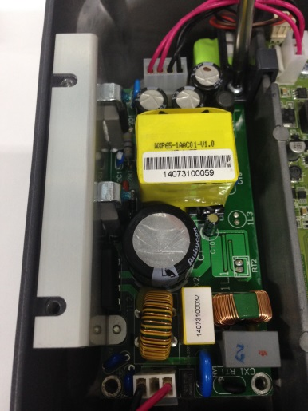

5.5 Replacing the DC/DC Board

Procedure for changing the board:

1. Lift off the platter and open the top housing (for details, please refer to the Opening the Housing chapter)
2. Unscrew the 2 bolts
3. Disconnect all cables plugged into DC/DC board
4. Remove the old DC/DC board
5. Install the new DC/DC board following the same instructions in the reverse order
6. Install the top housing

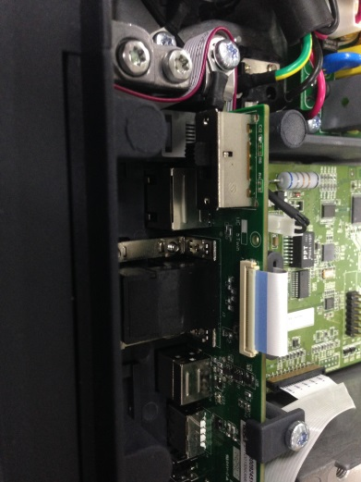
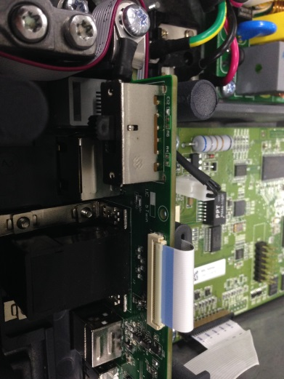
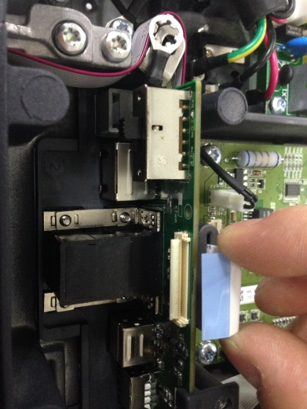

5.6 Replacing the A/D PCB

Procedure for changing the board:

1. Lift off the platter and open the top housing (for details, please refer to the Opening the Housing chapter)
2. Unscrew the 3 PCB bolts
3. Disconnect all cables plugged into A/D PCB
4. Remove the old A/D PCB
5. Install the new A/D PCB following the same instructions in the reverse order
6. Install the top housing

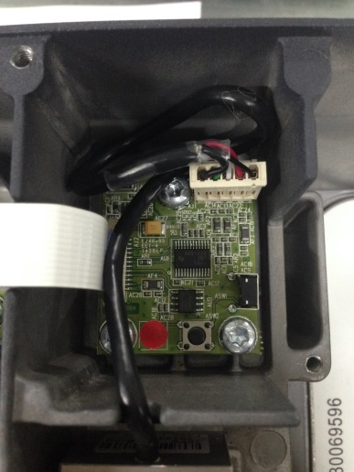
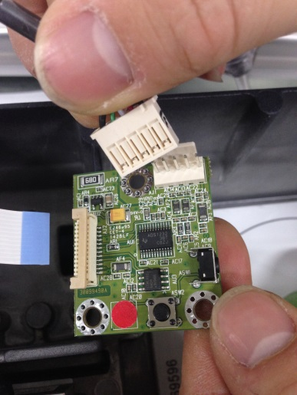
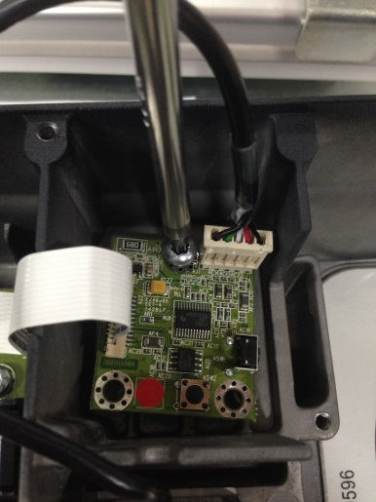

System restore procedure:

5.7 Replacing the Load Cell

Preparations

1. Write down the geo code

Procedure for changing the load cell:

1. Lift off the platter and open the top housing (for details, please refer to the Opening the Housing chapter)
2. Unscrew the 2 bolts
3. Disconnect all cables plugged into load cell
4. Remove the old load cell
5. Install the new load cell following the same instructions in the reverse order
6. Install the top housing

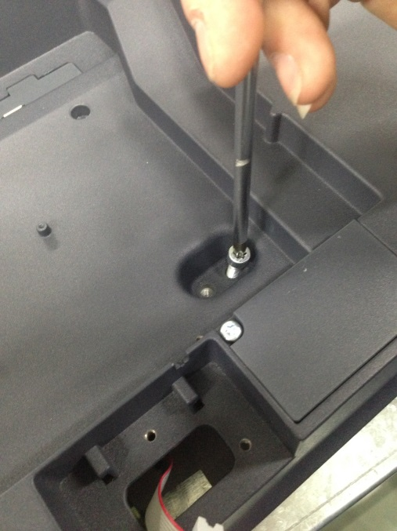
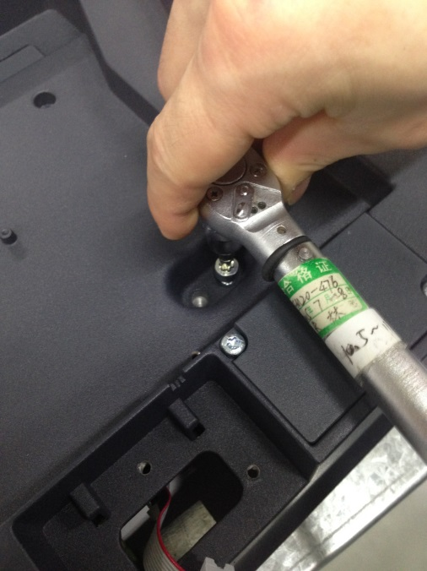

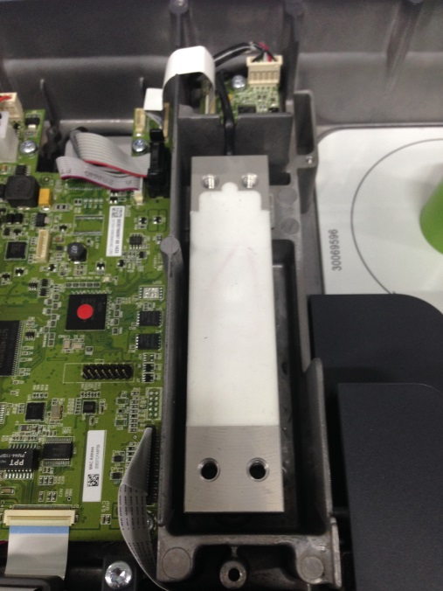
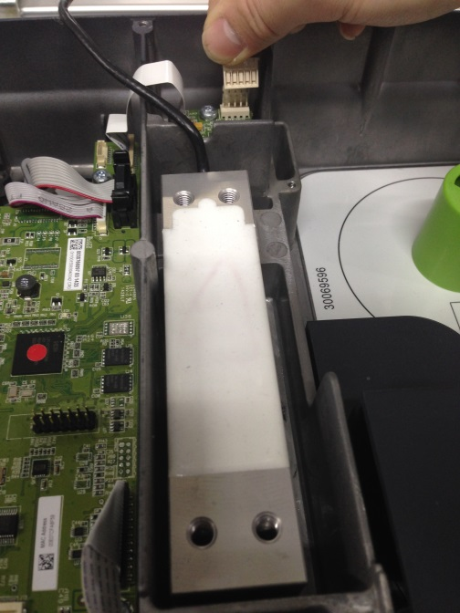

Attention:

Assuming the user is to use the (non-automatic) scales/balance in the legally regulated field, the user will be responsible for notifying the appropriate calibration authorities of the repaired scales/balance, so that the latter can take the appropriate measures (calibration/recalibration).

Calibration testing procedures:

- Repeatability Test

Purpose: Determination of the difference between several weighing processes for one load.
References: R76-1 (legal for trade)
Limits:

Levels All
Max. error Delta Span ≤ 1 Mpe

Weighing Max. error
0e<m<500e ≤0.5e
500e<m<2000e ≤1.0e
2000e<m<max ≤1.5e

Conditions: standard conditions

Procedure:

- 10 times individual weighing with full load (nearest the capacity). Position on the center of the plate
- 10 times individual weighing with 50% of full load (nearest the capacity). Position on the center of the plate.
o If necessary, repeat measurements with other loads and tare values.
o Measurements can be taken manually or automatically (computer test program or printer).
o In the case of a zero indication deviation between the weighing, the instrument shall be reset to zero without determining the error at zero.
o Record: indication of 3 individual weighing processes for each load, and time behavior of each weighing process.

Results:

Comparison of the indications with the required values, the highest and lowest indications for any given load should be within 1 mpe of each other.

- Linearity Test

Purpose: Determination of the repeatability (deviation in multiple weighing processes of the same load), and of the linearity behavior of the EUT.
References: Product description

Weighing Max. error
0e<m<500e ≤0.5e
500e<m<2000e ≤1.0e
2000e<m<max ≤1.5e

Conditions: standard conditions.

Procedure:

- 10 individual weighing processes at each load with at least 5 different loads (including zero point and full load). Suggested individual weighing with 0, 1/6, 1/3, 2/3, 1 of full load.
- When taking individual weight measurements at no load, tap the pan lightly to produce a visible change on the indicator. After the reading stabilizes, this indication is the zero or zero error reading for no load.
- Measurements can be taken manually or automatically (computer test program or printer).
- Recorded data: zero point and indication of 10 individual weighing processes at each load, and if necessary, the time behavior of each weighing process. \

Results:

Comparison of the indications with the 10 individual weighing processes of each load, the highest and lowest indications for any given load should be within 1 mpe of each other.

5.8 Replacing the Printer

Procedure for replacing the printer:

1. Lift off the platter and open the top housing (for details, please refer to the Opening the Housing chapter)
2. Unscrew the 3 bolts
3. Disconnect all cables plugged into printer
4. Remove the old printer
5. Install the new printer following the same instructions in the reverse order
6. Install the top housing

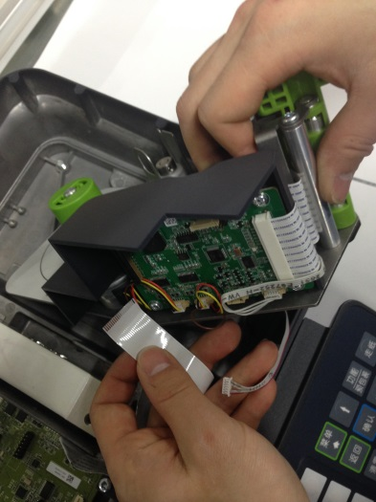
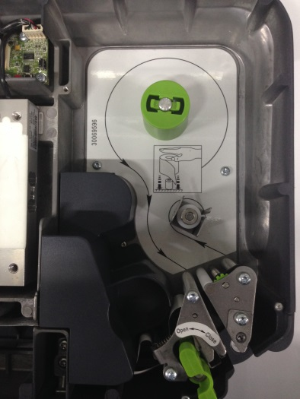
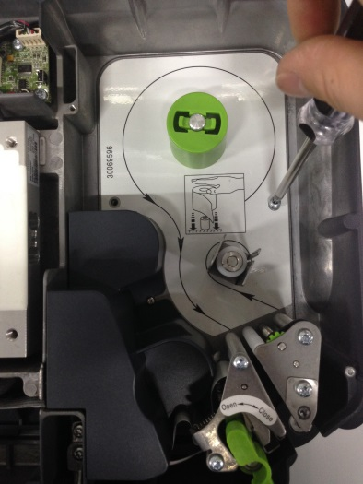

System Restore:

5.9 Replacing the Display

Procedure for replacing the display:

Replacing the operator side display

1. Open the display housing
2. Unscrew the 2 bolts on the housing
3. Unscrew the 2 bolts on the display board
4. Disconnect all cables plugged into the display board
5. Remove the old operator side display
6. Install the new operator side display following the same instructions in the reverse order
6. Install the display housing

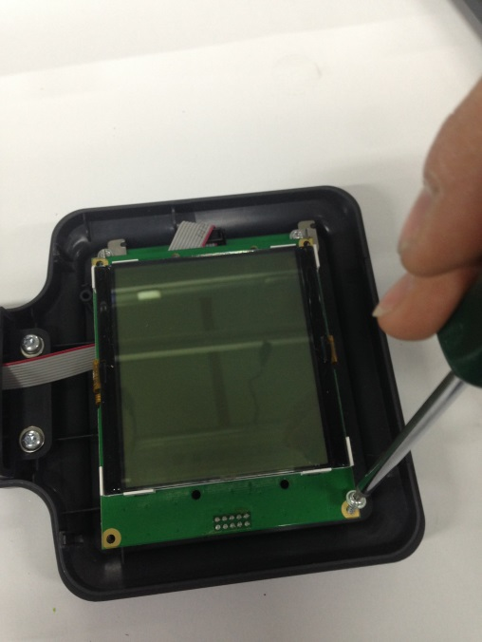
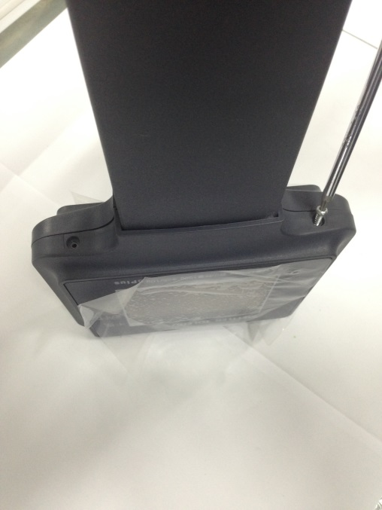

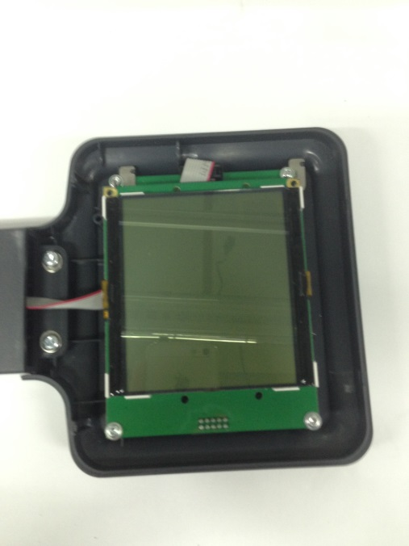
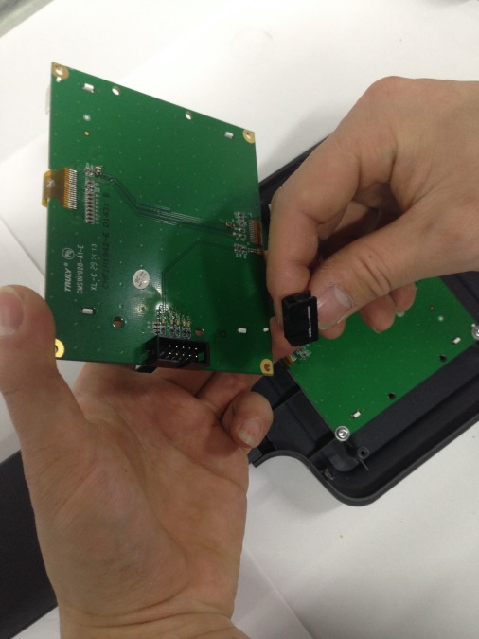

Replacing the customer side display

- Open the display housing
- Remove the old operator side display (for details, please refer to the Replacing the operator side display)
3. Disconnect all cables plugged into main PCB
4. Unscrew the 4 bolts on the display board
5. Remove the old customer side display
6. Install the new customer side display following the same instructions in the reverse order
7. Install the operator side display (for details, please refer to the Replacing the operator side display)
8. Install the display housing
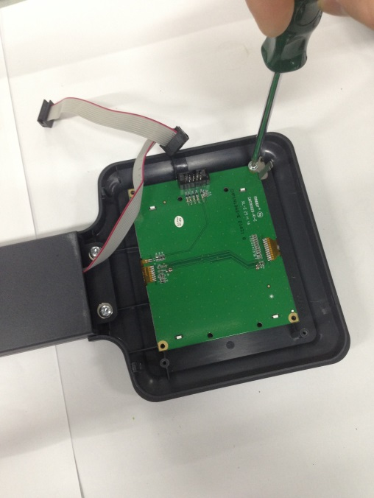
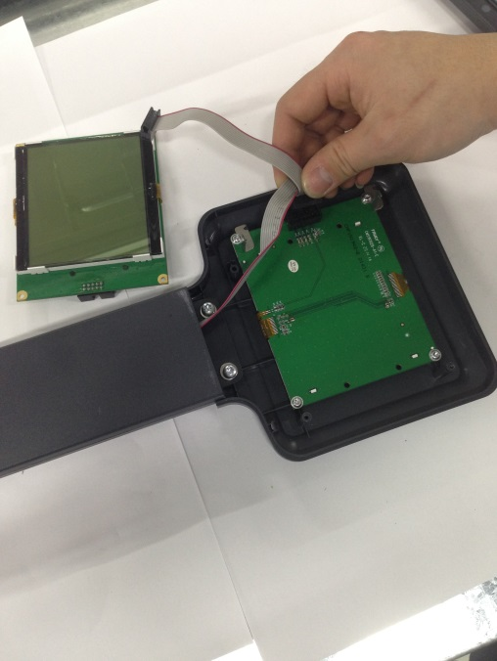

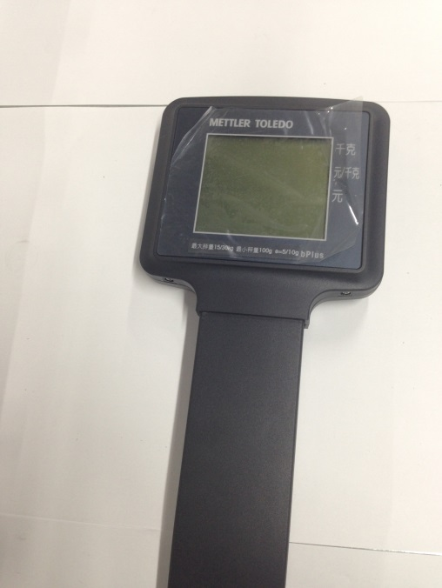
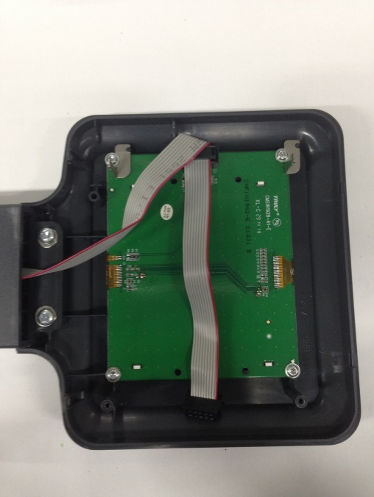

5.10 Replacing the Wireless Kit*

Procedure for replacing the interface:

1．Unscrew the 2 bolts on the tower base
2．Unscrew the 2 bolts on the wireless kit housing
3．Disconnect the wireless cable
4. Open the wireless kit housing
5．Unscrew the 2 bolts on the wireless kit
6. Disconnect the antenna harness
7．Remove the old wireless kit
8. Install the new wireless kit following the same instructions in the reverse order
9. Install the wireless kit housing

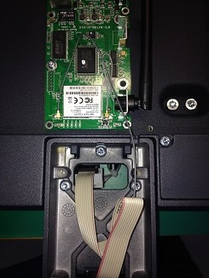
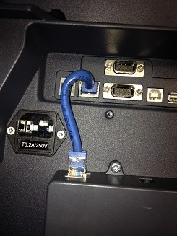
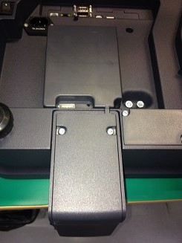

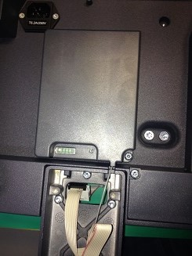
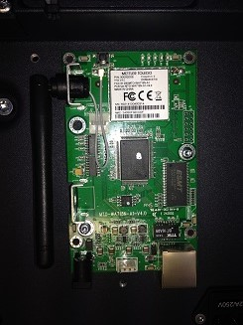
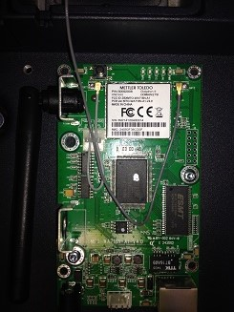

* Wireless option not available in all countries

5.11 Replacing the Fuse

Procedure for replacing the fuse:

1. Unscrew the 2 bolts on the fuse box
2. Take out the fuse with its box
3. Remove the old fuse
4. Replace it with the backup one
5. Install the fuse box following the same instructions in the reverse order

